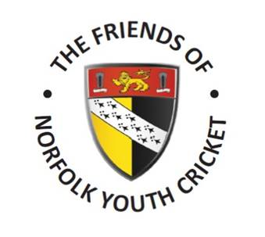

Registered Charity Number: 1177835
STANDING ORDER MANDATE
To:
The Manager

Bank, Building Society

Address
Please pay:
The Friends of Norfolk Youth Cricket
National Westminster Bank, 5 Market Place, Wymondham, Norfolk, NR18 0YY
Sorting Code 60-24-52 Account number - 15857816

Amount Occurrence (Tick appropriate box)
Annually
Quarterly
Monthly

Payment date
☐
☐
☐

Name

Address
Sorting Code Account Number

Print Name Signature

E-mail
Boost your donation by 25p of Gift Aid for every £1 you donate.
☐ Yes, I want to Gift Aid my donation to Friends of Norfolk Youth Cricket
☐ I confirm that I am a UK taxpayer and understand that if I pay less Income Tax and/or Capital Gains Tax in the current tax year than the amount of Gift Aid claimed on all my donations it is my responsibility to pay any difference.
After completion please:
Return to Kevin Denmark, FONYC Treasurer, Norfolk Cricket Board, c/o Horsford Cricket Club, Manor Park, Holt Road, Horsford, NR10 3AQ

